An ALTON-alternative Oil Seal for a Comet

There is no denying that Paul Harmon’s Alton alternator is one of the best things you can do for any Vincent that’s a regular on-road ride – it provides the basic building block of efficient, reliable and powerful electrics that can then support any combination of modern headlamp globes, upgraded ignition systems, turn indicators and for the ultra-modern rider, GPS and phone electronics as well.

Oil sealing, actually lack of it, is the Alton’s Achilles heel when being installed on a Vincent Comet (I have no experience with an Alton on any other bike)! The standard oil seal method is to smother the end face of your Alton with your favourite brand of silicon sealant, put the Alton in place on the motor and acting quickly adjust and tighten everything up before the silicon sealant starts to cure. Good luck!

This is all well and good and will work provided before you start applying the silicon you get ALL surfaces surgically clean – even the slightest trace of grease or oil on any surface where you hope for a seal will mean that the silicon will not bond securely to that surface and at some future date, always the most inconvenient time, oil will start leaking past the end of the body of the alternator, run down the back of the engine case and from there apply a constant stream of rust preventing oil to the rear of your Comet – especially the rear tyre! Not good.

Next problem: when you come to remove the Alton to try to fix the said leak you will discover another property of silicon sealant. It is an almost gorilla strength adhesive – and in the confines of the Comet cases there is no way you can get a knife (or scalpel) blade in there to cut the silicon away in order to free the Alton. Brute force is frequently required along with colourful and loud swearing, often over many hours. There has to be a better way!

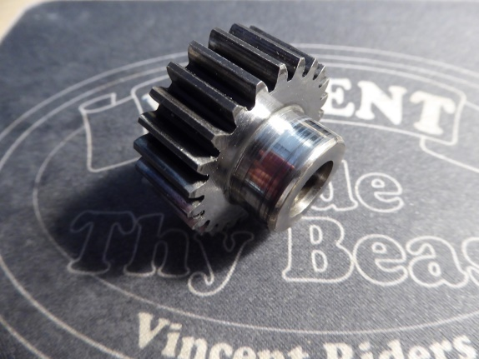Readers may remember that on the Comet the way the factory sealed the Miller dynamo was by means of E224, a lipped seal that is a press fit into the crankcase and runs on the shoulder on the rear side of the dynamo pinion E228.

Pictured is E228 where you can easily see the ‘surface’ that mates with E224 making a very effective and long lived oil seal. Note: this type of seal relies in part on the rotating surface to be highly polished – smooth.

I started wondering if a like seal could be applied to the Alton.

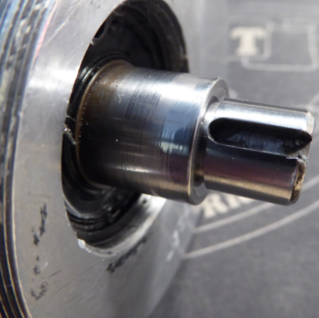Here is a picture of the drive end of my Alton. Look carefully and you will note the diameter of the drive shaft is largest where it exits the alternator body and it is then reduced in diameter to accommodate the drive gear. This photo was taken after I had polished the larger diameter part of drive shaft so ensuring a (future) lipped seal had a smooth sealing surface to run on.

Armed with the old E224 dynamo seal and my Alton I paid a visit to my local bearing supply house seeking a suitable lipped seal; one with an OD that would fit securely and oil tight in the crankcase opening and an ID that would be make an oil tight seal on the polished Alton drive shaft. What was found was a lipped seal with the description “Seal 18-35-7”; this has an ID of 18mm which is perfect for the Alton drive shaft, and an OD of 35 mm which is just 0.075mm larger than the 1 3/8” crankcase opening and has a depth of 7mm.

Pictured here is the original E224 used in conjunction with the Miller dynamo, alongside it (right) is the new 18-35-7 seal for use with the Alton. When installing ANY lipped seal the side with the garter spring MUST be on the oil source side.

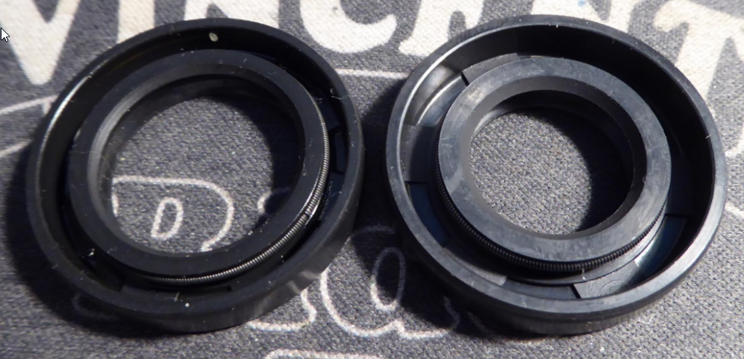

Installed, the end of the Alton’s body is to be flush against the outside surface of the crankcase so I installed the new seal so that the back of it was just below the outside surface of the crankcase – by about 1/16”, thus ensuring the Alton would mount flush as intended and that the seal would bear on the larger diameter portion of the Alton drive shaft. The seal is a firm press fit into the crankcase opening and I used a suitable drift to get the seal into the exact position sought, making sure it was not cocked in the opening.

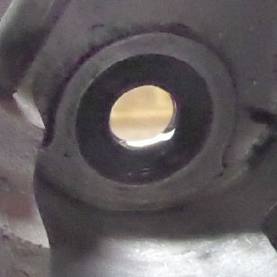 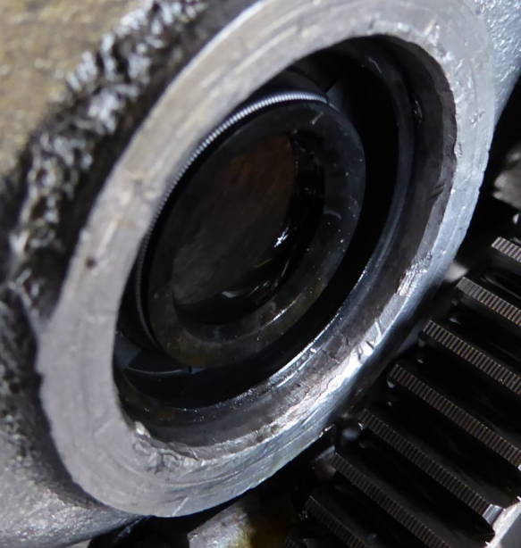

Here is the new seal in place from outside the crankcase, and right, from the timing chest side.

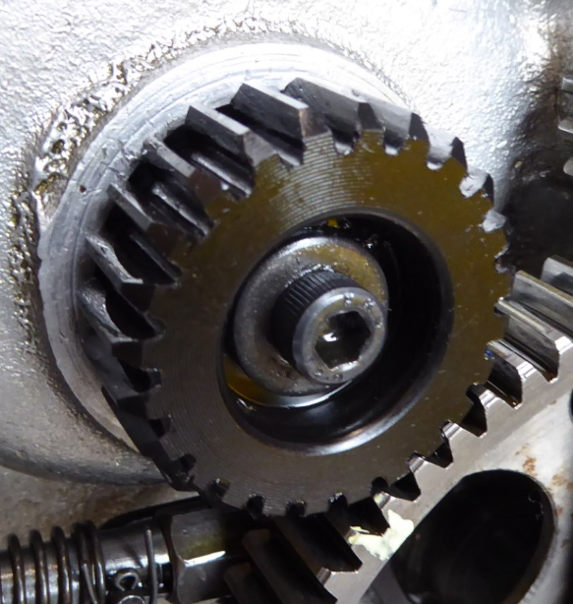Lipped seals ONLY work if there is a thin film of oil on the bearing surfaces, so be sure, as I did, to have a quantity of clean fresh oil on the seal surfaces as you assemble things. All that remained was to slip the Alton into position taking care to keep the drive shaft central within the lipped seal as lipped seals will NOT last long if the sealed shaft is not central and running true. The final photo is with all in place, ready for the timing cover to go back on.

After over 2,000 miles of on road testing with the new setup in my Comet I can report that the Alton installation, for the very first time, remains oil tight!